Create a react app for Student Management Portal named scorecalculatorapp and create a function component named “CalculateScore” which will accept Name, School, Total and goal in order to calculate the average score of a student and display the same.

1. Create a React project named “scorecalculatorapp” type the following command in terminal of Visual studio:
2. Create a new folder under Src folder with the name “Components”. Add a new file named “CalculateScore.js”
3. CalculateScore.js

import '../Stylesheets/mystyle.css'

const percentToDecimal=(decimal)=>{

    return(decimal.toFixed(2)+'%')

}

const calcScore =(total,goal)=>{

    return percentToDecimal(total/goal)

}

export const CalculateScore = ({Name,School,total,goal}) =>(

    <div className="formatstyle">

        <h1><font color="Brown">Student Details</font></h1>

        <div className="Name">

            <b><span>Name:</span></b>

            <span>{Name}</span>

        </div>

        <div className="School">

            <b><span>School:</span></b>

            <span>{School}</span>

        </div>

         <div className="Total">

            <b><span>Total:</span></b>

            <span>{total}</span>

            <span>Marks</span>

        </div>

         <div className="Score">

            <b>Score:</b>

            <span>

                {calcScore(

                    total,

                    goal

                )}

                </span>

        </div>

    </div>

)

1. Folder named Stylesheets and add a file named “mystyle.css”

.Name

{

    font-weight:300;

    color:blue;

}

.School

{

    color:crimson;

}

.Total

{

    color:darkmagenta;

}

.formatStyle

{

    text-align:center;

    font-size:large;

}

.Score

{

    color:forestgreen;

}

5.App.js

import './App.css';

import {CalculateScore} from'../src/Components/CalculateScore';

function App() {

  return (

    <div>

      <CalculateScore Name={"Hema"}

      School={"ABC public School"}

      total={290}

      goal={3}

      />

    </div>

  );

}

export default App;

6 . 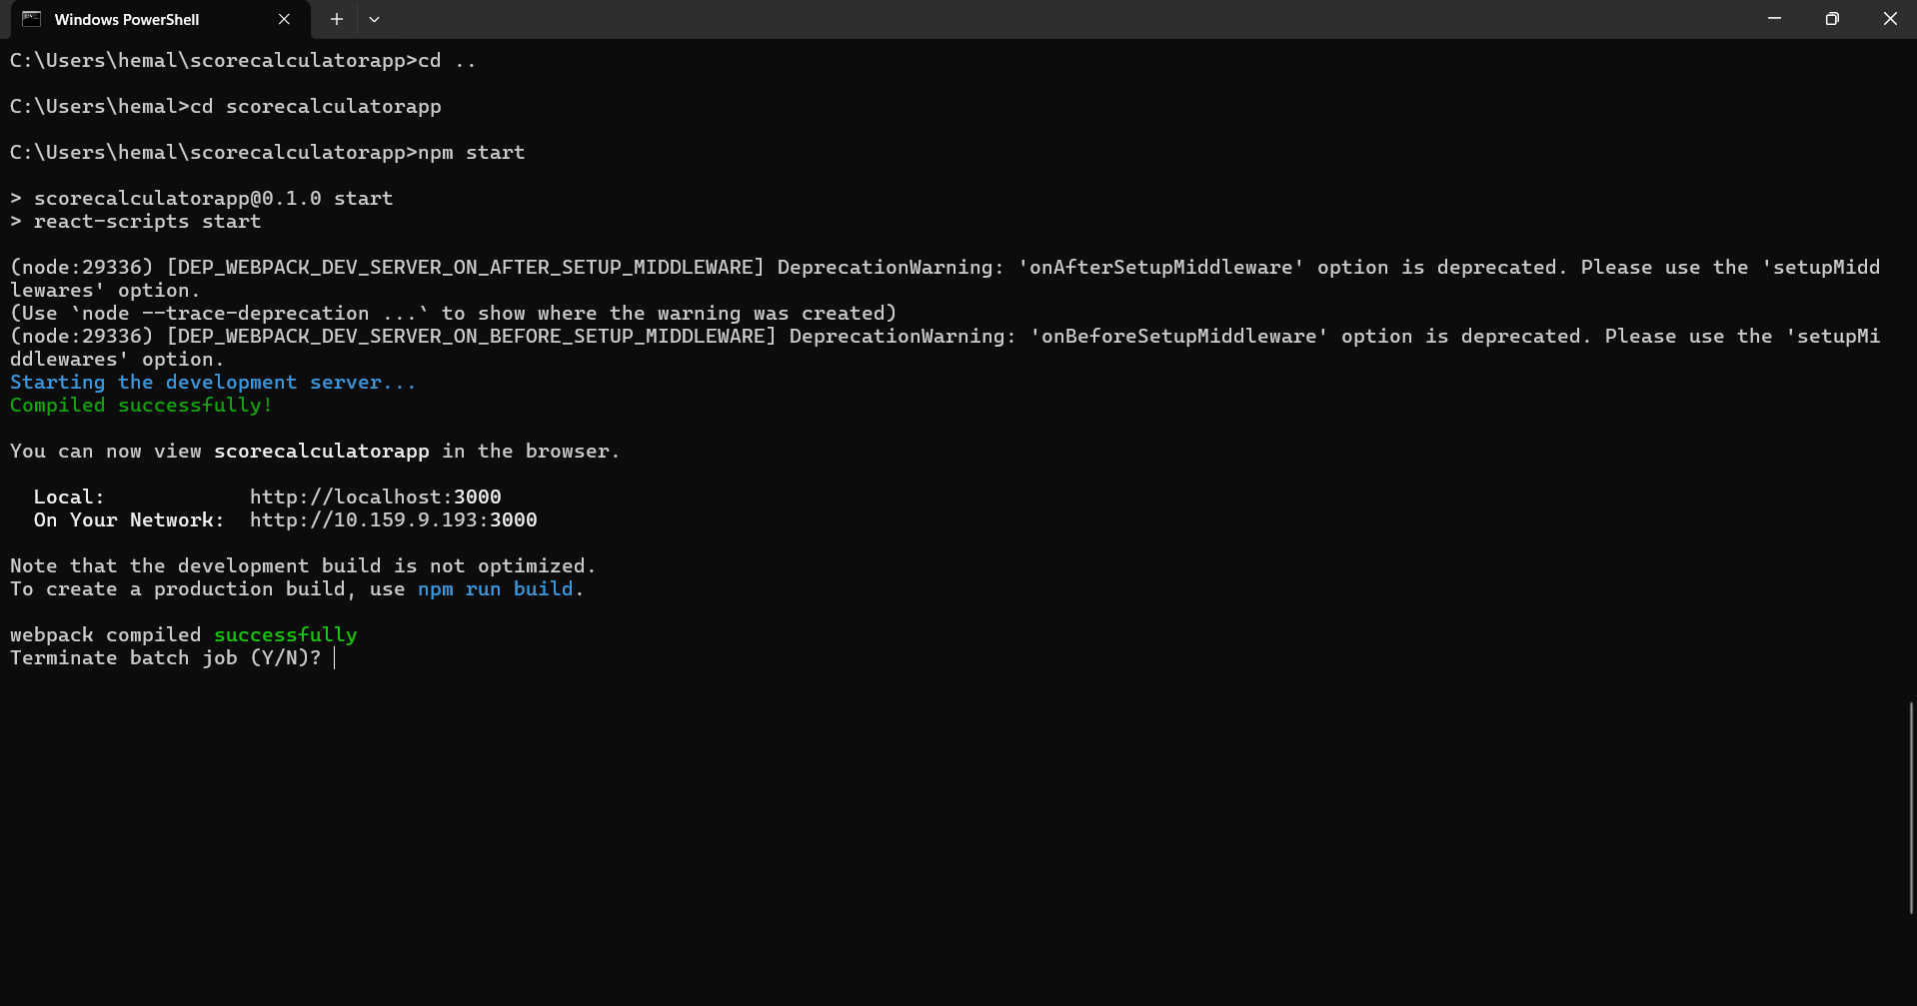

7. Open browser and type “localhost:3000” in the address bar:

